Ideation Phase
Define the Problem Statements

Date | 25/09/2026
Team ID | SWTID-2026-3184
Project Name | AI Studdy Buddy
Maximum Marks | 2 Marks

Customer Problem Statement:
College students often face difficulty understanding complex academic topics and finding quick, simple, and reliable explanations when studying independently. Existing study resources may be lengthy or difficult to understand, making students feel confused and frustrated. Therefore, there is a need for an AI Study Buddy that provides instant, simple, and relevant explanations based on the student's questions.
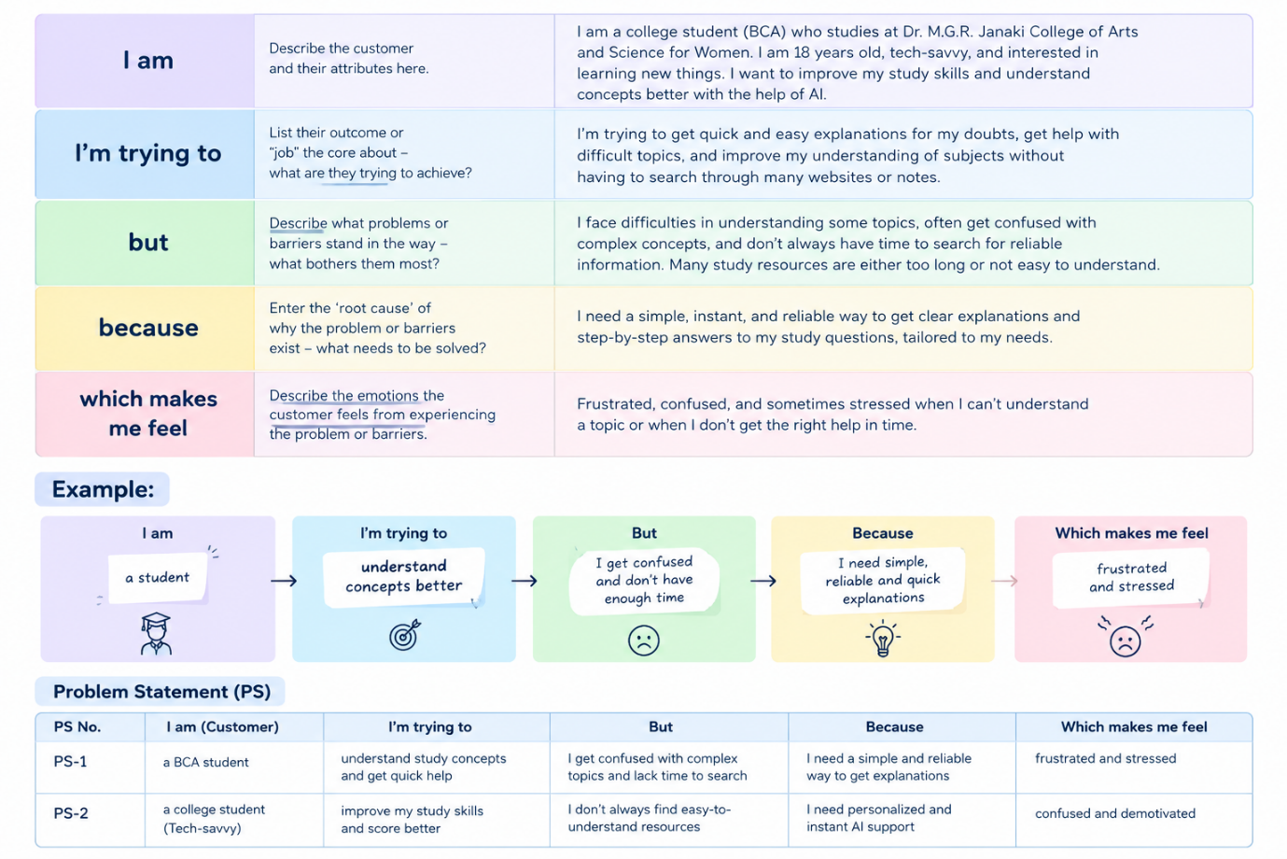
Example:
Problem Statement (PS) | I am (Customer) | I’m trying to | But | Because | Which makes me feel
PS-1 | A BCA student | Understand study concepts and get quick help | I get confused with complex topics and lack time to search | I need a simple and reliable way to get explanations | Frustrated and stressed
PS-2 |  | Improve my study skills and score better | I don’t always find easy-to understand resources | I need personalized and instant AI support | Confused and demotivated
  A college student

